

SmarTone-Vodafone
ADW Project

ETL Technical Specification
Version 1.15
15 November 2005



SmarTone-Vodafone & NCR Confidential
ETL Technical Specification
document preparation information
project name | prepared by (print) | signature | date prepared | DOCUMENT ID
SmarTone-Vodafone ADW Project | Branco Li |  | 9/28/2005 | ETL Technical Specification
Customer information
Customer | Contact | Customer Account
SmarTone-Vodafone | Eva Chan
GENERAL INFORMATION
project manager | security classification
Ken Chan | NCR and SmarTone-Vodafone Confidential
ORIGINATOR INFORMATION
ORIGINATOR |  | NCR ORGANIZATION NAME
Ken Chan |  | Teradata Division
NCR Organization ADDRESS
22/F RBS Tower, Times Square, Causeway Bay, Hong Kong
PHONE NUMBER | FAX NUMBER |  | E-MAIL
2859-6048 | 2548-4679 |  | ken.chan@ncr.com
VERSION INFORMATION
LAST UPDATED | MASTER VERSION LOCATION*
Version 1.14 | NCR / SmarTone-Vodafone Project Office
*For detailed information, see Guidelines below.

Note: The reader must verify that this is a current version before using.
CUSTOMER Acceptance
NAME (PRINT) | SIGNATURE |  | DATE
PHONE | FAX | E-MAIL
NAME (PRINT) | SIGNATURE |  | DATE
PHONE | FAX | E-MAIL
Guidelines
Master Version Location | \\SHK_DEMO0CMS\CMSPROJS\Telecom\SmarTone ADW Project\Document\SMC-V ADW Project - ETL Technical Specification.doc

Document Control
document distribution
name | title | organization
 |  | SmarTone-Vodafone
 |  | SmarTone-Vodafone
 |  | SmarTone-Vodafone
 |  | SmarTone-Vodafone
Garrett Siu |  | NCR
Ken Chan |  | NCR
Bun Wong |  | NCR
change history
date | change description | approved by
28 Sep 2005 | TOC review version
22 Oct 2005 | Added details to all items
26 Oct 2005 | Modifications after internal review
4 November | Modifications after SMC-V feedback
15 November | Add Special Handling Script parameters

Table of Contents
1. ETL overview 6
2. Logical Process Flow 6
2.1 data sources 7
2.1.1 Pulling 8
2.1.2 Pushing 8
2.1.3 Extracting 8
2.1.4 Staging Area 8
2.2 Data Files pre-processing 9
2.2.1 Typical Functionalities of the Pre-process Daemon 9
2.2.2 The Pre-process Configuration Tables 9
2.2.3 Data File Wildcard Matching 14
2.2.4 Control File and Data File Structure 15
2.2.5 Using Special Handling Script 16
2.2.6 Restartable Pulling Process 16
2.2.7 Loading Variance Factor – Checking Type 16
2.2.8 Loading Variance Checking Mechanism 17
2.2.9 Programming Languages 17
2.2.10 Process Flow Design 17
2.2.10.1 Pre-process Daemon 17
2.2.11 Pre-process related Directory 23
2.3 DATA Transformation AND loading approach 24
2.3.1 Upsert 24
2.3.2 Replace 25
2.3.3 History 25
2.3.4 Append 26
2.3.5 Table Image Switching Approach 26
2.3.6 CDR Table Implementation 26
2.3.7 Duplicate Row Handling 27
2.4 Post processing 27
2.4.1 Output Variance Checking 27
2.4.2 Table As_of_Date and Refresh_date 28
2.4.3 Table Collect Statistics 29
3. etl Automation 29
3.1 Batch Window 29
3.1.1 Night Batch Loading 29
3.1.2 Immediate Loading 30
3.1.3 File Directory Flow 30
3.1.4 Running Jobs Multiple Times a Day in ETL Automation 31
3.1.5 Job Re-run 32
3.1.6 ETL Automation Directory 32
3.2 password encryption 33
4. HP Openview 33
5. Appendix 33
5.1 etl automation operation introduction 33
5.1.1 Overview 34
5.1.2 Daily and Monthly Job Setting 38
5.1.3 Environmental Parameter File 39
5.2 Datastage operation introduction 40
5.3 ETL Performance tuning 40
5.3.1 Partitioned Primary Index 41
5.3.2 Secondary Index 41
5.4 Identifiable Error Messages 41

ETL overview

ETL plays an important role in modern data warehousing technology. This involves extracting data from outside source systems, transforming data to fit in the data model, and loading data into the data warehouse. In extraction, data image are captured into data files. The data files exist either as fixed width or delimited records. The data files are further manipulated and massaged into appropriate format. Code conversion, merging and transformation will take place. The final stage loads the data based on different approaches depending on nature of data and business need.

Logical Process Flow
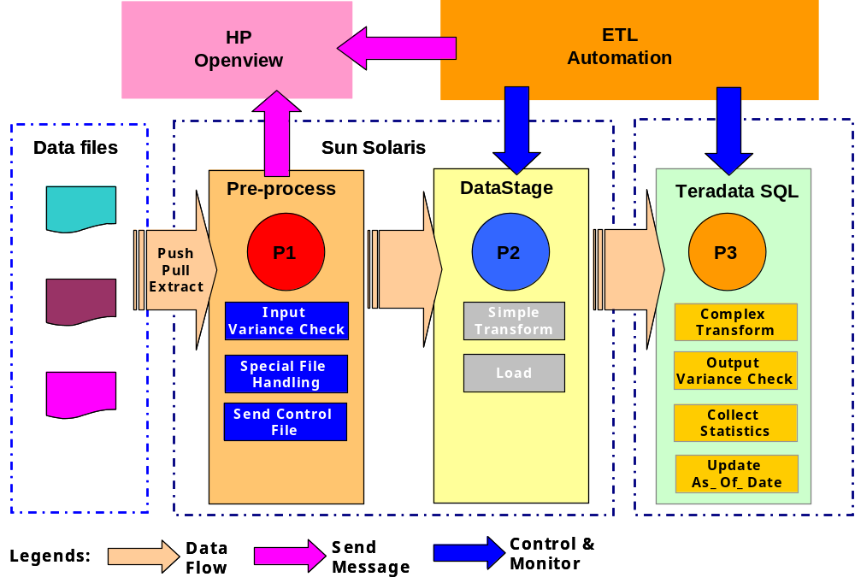

- Data sources come from various machines. Some of them are pushed to staging area periodically, while other may require pulling and extracting.

- The Pre-process daemon will handle the arrival of data files. It imposes checking on files and save results for variance checking. It also calls special handling scripts to perform specific decrypt, transpose handling. At last, it generates control files to notify starting of an ETL job.

- DataStage takes part in some simple transformation and loading jobs.

- For more complex and heavy transformation, it will be done by Teradata SQL. The data variance checking and reject record checking will also be done in Teradata during post processing stage. After all, the table is collected statistics.

- ETL Automation will control the overall process of ETL jobs. They includes DataStage transformation and loading jobs, Teradata transformation jobs, and statistics logging. It executes these jobs according to their pre-defined dependency in its repository.

- HP Overview will be the primary monitoring console for all components. For detailed troubleshooting of job failure, it is required to refer to ETL Automation and detailed job log.

The ETL processes are mainly classified into 3 stages:

- P1 – The Pre-process stage handles different sources and verifies the files to see if they are suitable for loading.
- P2 –The DataStage stage is responsible for simple transforming and loading the data into Teradata.
- P3 – The Teradata SQL stage further manipulates the loaded tables and integrates the data into existing table image.

The following sections will explain these stages in details.

data sources
There is a variety of source systems for SmarTone-Vodafone. For the ease of design and implementation, a set of application abbreviation codes will be used to represent them. This provides logical grouping of scripts, data files, and helps to avoid file name duplication from different source systems.

The abbreviation codes are summarized as below:

Data Source | Data Source Code
Application Server | AS
Billing System | BLS
Front End System | FES
Mediation Device | MD
Mobile Number Portability | MNP
OM | OM
Oracle Finance | ORF
Prepaid Console | PPC
Users | USR

Data files from various source systems should arrive at the Sun Solaris staging area. They are captured by three ways:

Sun Solaris
Extract
Push
Pull
Staging Area

Pulling
Some data files exist in FTP servers or trusted Unix servers. It is required to get them by file transfer protocol (FTP) or remote file copy (RCP). A pair of login and password will be needed for FTP, while just a trusted login is used for RCP. Pulling will be further mentioned in Pre-processing.

Pushing
This kind of method mainly used for the files from Mediation Devices. The files are pushed by these devices to the staging area.

Extracting
The source data exists as a table or set of tables in an OLTP system. An extraction job is needed to login the database to get the required data. The extraction job either produces text files ready for loading, or loads the tables to Teradata directly using DataStage. This will be further mentioned in Pre-processing.

Staging Area
This area is a physical disk device mounted to Sun Solaris. Its size should be large enough to hold data for a number of days in order to support job re-run. Concerning space limitation, huge CDR files will be flushed after loading, while other files can be kept in staging area for longer period. If CDR related jobs require re-run, special handling will be done manually.

This is also advisable to be one single device since Pre-process daemon and ETL Automation will rename and move files among directories. Therefore, the use of single device can avoid large data movement.

Data Files pre-processing
In order to capture data from all sources, there is a need to have a central process to manage different arrival patterns of data files. A pre-process module is designed to act as the primary data file handler. All data files should undergo it prior to ETL Automation loading. As this pre-process is required to support monitoring capability, this should be implemented as daemon program.

Typical Functionalities of the Pre-process Daemon
The daemon provides the following basic functions:
- Monitor arrival of data files and control files
- Trigger file pulling and extraction sub-task on dedicated schedule
- Verify file by variance and determine if the file is ready to load
- Truncate and validate header/trailer for loading jobs
- Massage data files (E.g. Transpose, Decrypt)
- Generate standardized control files and data files for ETL Automation processing
- Log file statistics for calculating variance.

The Pre-process Configuration Tables
Three tables will be used to define the source file characteristics and file checking rules. The pre-process daemon will handle the file according to the values of these attributes, and finally determine if the corresponding EA loading job can start, or generate necessary messages to notify relevant parties.

Table name: ETL_SRC_FILE

The table stores the attributes to tell the daemon how to handle data file arrival and call generic child module to pre-process the file case by case.

Attribute Name | Description |  | Format and Possible Values
Filename_Mask | For pulling or pushing data source, it is the file name mask to match a set of files based on the defined pattern.  It allows the following 3 types of pattern variables:  [date] – date portion  *– Multiple alphanumeric chars  [n] – One digit  [n][n] – Two digits  [n][n][n] – Three digits  [date] will be substituted by the system date to match data files. This allows one occurrence only.  * is the wildcard for the data filename. This allows one occurrence only.  [n] represents a digit that allows a number of occurrences.  For Billing system, this attribute will contain a control file name to specify readiness of multiple file sets in the same remote directory.  For data source extracted directly from database, it is the DataStage job name. These jobs are located in a predefined directory. |  | E.g.  [date].card.z  zone_reg_[date].txt  [date]*.cli  billing_[date].ready  ds_load_rateplan
Filename_Date_Format | It is the argument used in Unix date command to tell how the variable date portion “[date]”in the Filename_Mask is substituted by a system date. |  | E.g.  %Y%m%d
Data_Path | Directory location for the data files  For pulling, data files are pulled from this directory  For extracting, data is extracted to put on this directory  For pushing, this is the monitoring directory |  | E.g.  /opt/etl/data/arrive/fes
Job_Name | The name used to derive data file name and control file name for ETL Automation. The Job_Name should compose of a meaningful name related to the table and its data source abbreviation at the beginning.  If this field is null, no control file and data file will be generated to EA. This is the case for special condition, that Billing System source is putting control file to indicate readiness for a set of data files. Please refer to the Using Special Handling Script for details. |  | E.g. md_loadcdr
Date_Offset |  | The number of offset days used to make adjustment on the system date for locating valid data files. Sign is meaningful to this field. | 0
File_Locate_Type |  | Method of locating the data files | PF – Pull FTP  PR – Pull RCP  PS – Push  EX – Extract  CP – Copy
Special_Handling_Script | The file name of specific special handling script required to run. (E.g. transpose, decrypt, header-trailer validation). |  | dw_load_ringcity.pl  bs_ftp_billing.ksh
Pull_Ip_Address | IP address or DNS name for locating the file for ftp and rcp pulling |  | 172.20.252.100
Pull_Login | Login user id used to get file via ftp or rcp |  | adwbat
Pull_FTP_Port | Special port required for FTP other than standard port |  | 6006
Pull_FTP_Mode | File transfer mode |  | B – Binary  A – ASCII
Pull_Remote_Path | Remote directory storing the data files to pull.  This value should NOT contain “/” at the end.  If “[date]” exists in the path, it will be replaced by system date according to the format specified in Remote_Path_Date_Format |  | /log/logbak/CDR/[date]  /xera/warranty
Remote_Path_Date_Format | It is the argument used in Unix date command to tell how the variable date portion “[date]”in Pull_Remote_Path is substituted by a system date. |  | %Y%m%d
Pull_Start_Date_List | It is a list of execution frequency date codes controlling data file pulling. Each frequency code is delimited by a comma. Pulling starts if any one code is matched.  The format is:  <Freq_Code1>,<Freq_Code2>  A frequency code is comprised of 3 parts. Each part is delimited by a colon, and follows the date specification of crontab in Unix.  The specification is:  <Day in month>:<Month>:<Week day>  Each part allows an asterisk to represent a wildcard.  E.g.  *:*:* means pulling file everyday  30:*:* means pulling file on 30th every month. (Note that February won’t have 30th day, so there will not be February run)  6:1:*,6:4:*,6:7:*,6:10:* represents a file pull on the 6th day of Jan, Apr, Jul and Oct. |  | 6:1:*,6:4:*,6:7:*,6:10:*
Pull_Start_Time_List | It is a list of expected time in HH:MM 24 hour format up to minute. Hour part and minute part is delimited by a colon.  This will be used together with Pull_Start_Freq_List to determine if the file needs to pull. |  | 01:00,13:00
Pull_Retry_Count | The number of retry allowed before an error message is sent to HP Openview |  | 5
Retry_Wait_Minute | The wait time in minutes to wait before the next retry. |  | 10
Data_File_Retention_Period |  | The number of days where data files are kept. Data files older than this number of days will be cleaned up. | 7
Unzip_Command |  | The command with argument to be called to unzip a file.  Complex combination of different unzip types (E.g. gunzip, tar, zcat) will be done by the script specified in Special_Handling_Script field. | gunzip %1 –c > %2
Check_EA_Fail_Dir_Flag |  | Y – The pre-process will check for previous job failure in EA Fail directory before sending control file to EA. If control file is found there, pre-process does not trigger the EA loading job. It will then wait for minutes in Retry_Wait_Minute and retry.  N – The pre-process does not check EA Fail directory. | Y
As_Of_Date_Determine_Method |  | The way to determine the data As_Of_Date | N – From file name itself  T – From file timestamp
Last_Process_Time |  | System date time for last processing on this file set | 2005-10-24 10:12:25
Last_Process_Status |  | The status for last processing | S - Success  F – Fail  P - Processing
Last_File_As_Of_Date |  | The last valid file As_Of_Date determined during file pre-process | 2005-10-24 00:00:00

Table name: ETL_FILE_VALIDATION_RULE

Per each data file set, checking rules can be defined to validate it. Each rule is designed to generate a file validation failure message if its condition is fulfilled. In short, all rules are OR’ed to determine the file validity.

Attribute | Description | Possible Value
Filename_Mask | This is foreign key to  ETL_SOURCE_FILE.Filename_Mask | Refer to foreign key ETL_SOURCE_FILE.Filename_Mask
Data_Path | This is foreign key to  ETL_SOURCE_FILE.Data_Path | Refer to foreign key ETL_SOURCE_FILE.Data_Path
Check_Type | Types of checking rules | RC – File record count  FC – File count  FS – File size in bytes  DV – Data Variance  RR – Rejected record sent to error tables after loading  OC – Output Record Count
Percentage_Fixed_Value | The value used for the checking | F - Fixed Value  P – Percentage  A – Both Fixed Value and Percentage are checked
Rule_Activate_Flag | The flag to activate or deactivate this rule | Y – This rule is activated and in effect  N – This rule is deactivated
DV_Check_Field_Name | The numeric field that needs to impose aggregation check. | Total_Call_Minute
DV_Aggr_Func | The database function used to aggregate the checking field | AVG  SUM  MAX  MIN
Min_Margin | The min margin used for fixed value rule checking | 8,000
Max_Margin | The max margin used for fixed value rule checking | 10,000
Past_ Variance_Use_Count | The number of times of available variance information used for checking variance by percentage. | 7
Margin_Percentage | The positive and negative margin percentage used to validate the data file based on past loading history.  5 implies + - 5% | 5

Table name: ETL_FILE_VALIDATION_HIST

This is the history table to store file validation statistics. The content will be used to calculate variance value.
Attribute | Description | Possible Value
Filename_Mask | This is foreign key to  ETL_FILE_VALIDATION_RULE.Filename_Mask | Refer to foreign key ETL_FILE_VALIDATION_RULE.Filename_Mask
Data_Path | This is foreign key to  ETL_FILE_VALIDATION_RULE.Data_Path | Refer to foreign key ETL_FILE_VALIDATION_RULE.Data_Path
Check_Type | This is foreign key to ETL_FILE_VALIDATION_RULE.Check_Type | Refer to foreign key ETL_FILE_VALIDATION_RULE.Check_Type
Check_Timestamp | The timestamp performing the checking | 2005-09-21 14:00:00
Table_Name_List | List of the final ADW table(s) name where this file goes to. It serves for troubleshooting purpose. | subr_info_hist, cust_info_hist
Result_Value | Result for the check type on the data file at a time | 100

Data File Wildcard Matching
The following describes how to get candidate data files:
- The system date is captured.
- It is then adjusted by its offset value. The offset will have a default zero value. In case of running job to cater earlier data files, it is set to a negative value to adjust the file matching date.
- The adjusted date is fitted into the date portion in the file name mask, according to its format specified in Filename_Date_Format. In short, [date] is replaced by the adjusted system date.
- The filename mask is further processed by replacing every [n] by [0-9].
- The final string is a regular expression for Unix “ls” and “grep” to match files.

Control File and Data File Structure
A control file indicates the completeness and readiness of its set of data files. It is a text file with standardized filename and file format generated by the pre-process daemon. It is used by ETL Automation for job triggering and dependency control. When a control file is tracked, ETL Automation will read its content and compare the physical file size of the data file. If file size is matching and no other dependency is pending, the job is executed.

The control filename is generated as the format below:
Format:
dir.<Data_Source>_<Job_Name>_<YYYYMMDD>

E.g.
dir.md_loadgprs_20051024

Each row in the control file follows the structure below:
Format:
<Job_Name>_<Orig_Filename>_<YYYYMMDD>

E.g.
Assume that:
Orig_Filename is gprs_20051024
Job_Name is md_loadgprs
System date is 20051024

Control file will contain:
md_loadgprs_gprs_20051024.dat_20051024

In which:

- <Data_Source> is the 2-3 chars abbreviation code of data sources
- <Job_Name> is job name for the loading job
- <Orig_Filename> is the original filename during wildcard matching
- <YYYYMMDD> is derived from system date and adjusted by an offset.

Using Special Handling Script
The value in Special_Handling_Script column provides the name to call a shell script. This can solve specific problems and provide high level of flexibility. Currently, it is used in 2 areas.

Perform Specific File Processing
It involves transpose, decrypt, header trailer removal, complex unzip, and Excel file massage. Individual scripts are called to handle the tasks.

Control File Generated from Data Source
Billing system provides data once a day. A control is placed when all data files are ready. However, the data files may be of different masks and should be processed separately.

In order to handle this case, an extra row is added to the pre-process configuration table. This row contains the specific control file name as in the Billing system directory. When the control file for the date is found, it triggers a special script to copy all candidate files for today to different local sub-directories. The files will be copied firstly to a temp sub-directory and then renamed finally to make the process atomic. Once the directory is renamed, it will further trigger corresponding pre-processes. The Job_Name attribute of this special row is set to null to avoid the generation of EA control file.

Parameter Passing Schematic for Special Handling Script

There are 2 arguments passed to the special handling script:

- IN_DATA_PATH
This variable tells the script the full path location of input data files. The special handling script should treat all files there as candidates for its processing.

- OUT_DATA_PATH
The special handling script should place its output files here.

Calling Example:
...

cd /opt/etl/MD/work/20051115.10901/IN

$SCRIPT_PATH/special.ksh /opt/etl/MD/work/20051115.10901/IN
/opt/etl/MD/work/20051115.10901/OUT

wait

rc=$?
if [ $rc –eq 0 ]; then
...
else
...
fi

The script should be placed at “~/preprocess/<Data_source>/script “ directory.

At the beginning of the special handling script, it can include the following 2 lines to get the arguments:

IN_DATA_PATH=$1
OUT_DATA_PATH=$2

The special handling script should properly return its exit code.
- = 0 Success
- <> 0 Failure

Restartable Pulling Process
The pulling process of large files often takes a long period of time. The chance of aborted ftp, rcp, and copy cannot be ignored. Regarding this, the pulling mechanism is designed to be able to restart at its failure point.

A pulling will perform the following:
- A token file is touched at the beginning of pulling to indicate it is in-action.
- Then, pulling will run
- The token is finally cleaned up if the process completes successfully

If a pulling is aborted in the middle, the daemon will observe that an orphan file token remains there but have no corresponding process running. The daemon will restart the entire pulling process. The restarted pulling process will diff the source and target directories by file name and file size first to ensure completed files are not re-transmitted.

Loading Variance Factor – Checking Type
The following measurement figures are required to check for loading variance:
- Data File Size – The size of data file in bytes is verified with the history size of the same file.
- Data File Count – The number of files in a set to load.
- Data File Record Count – The number of record in the file is verified with the historical record counts of the same file.
- Data Variance – The aggregated value (I.e. SUM, AVG, MAX and MIN) of a chosen numerical field from the loaded table is verified against its previous history.
- Rejected Record Count – This means the total record count as found in error tables (I.e. E1 and E2 tables for FastLoad, ET and UV tables for MultiLoad) during loading.
- Output Record Count – The number of successfully loaded records.

Data file size, file count and file record count are checked during pre-process stage as the Input Variance Checking.
Data variance, rejected record count and output record count are checked during post-ETL process as the Output Variance Checking.

Loading Variance Checking Mechanism
There are two checking mechanisms used:
- By a fixed margin value range
- By a margin percentage, calculated based on past n days of history

Exception for Variance Checking

If a data file is rejected due to variance exceeded, its measurement figures (I.e. File Size, Record Count and Numeric Field Aggregate) will NOT be inserted to the ETL_FILE_VALIDATION_HIST table. Hence, it is NOT used for calculating the variance for the next time. This can avoid checking variance mechanism being affected by any bad or fluctuating figures.

If the information in the ETL_FILE_VALIDATION_HIST table does not have enough history, the average value will still be calculated. For example, there is only three days of history but it is required to take average of seven days. In this case, average of the three days will be used as the variance checker.

Programming Languages
The daemon will be written mainly using KornShell script. C language may be used whenever required to implement small modules.

Process Flow Design
The pre-process mechanism is implemented as daemon, namely the Pre-process daemon.

Pre-process Daemon
The Pre-process Loop Body

The daemon will firstly look for the exit file token (exit.token). If it is found, it terminates. Otherwise, it enters a loop body.
- The file information from configuration table is captured.
- It will firstly check the special rerun directories for file and call File Processor sub-process to handle it.
- Then, it repeatedly forks sub-processes for the right candidates to perform pulling or extracting.
- Then, it repeatedly checks for each monitoring directory. If any file found, it forks a File Processor sub-process to handle it.
After a sequence of these steps complete, it sleeps for a predefined number of minutes and repeats from the exit file token checking.

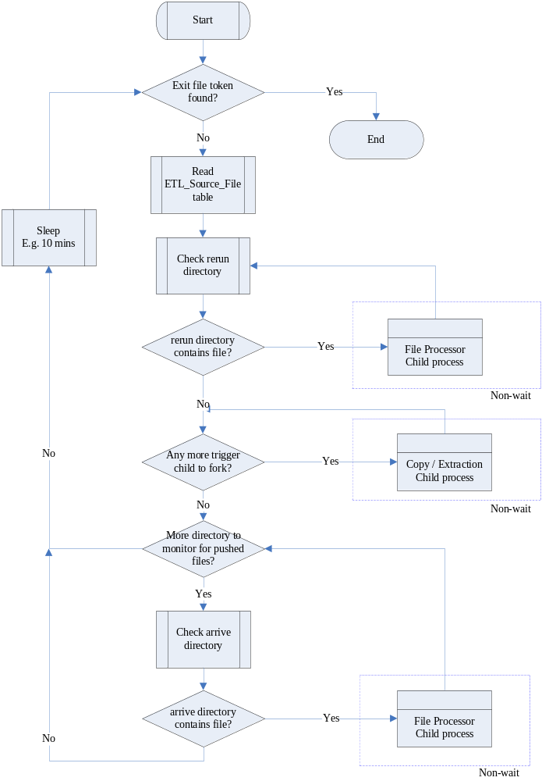

The Pull/Extract Child Process

This is the child process forked by the Pre-process daemon. It receives the file information and performs pulling by either an ftp, rcp, copy or extraction script. Upon completion, it either places files to the Arrive directory or sends error message to HP Openview.

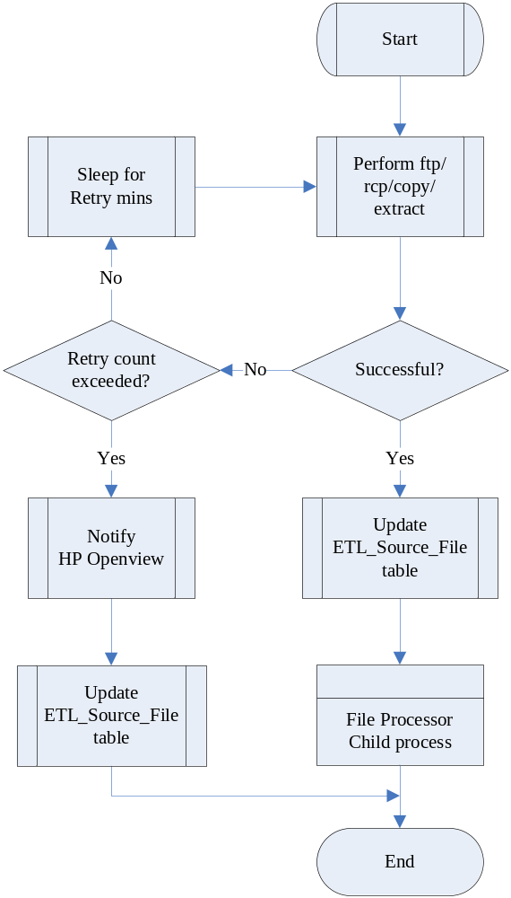

File Processor Child Process

It is the child process called by either the pre-process daemon or the pull/extraction child process to handle a file set. It performs all required processing on the set based on the configuration table. Finally, it will either reject the files by sending message to HP Openview or create EA control file for loading.
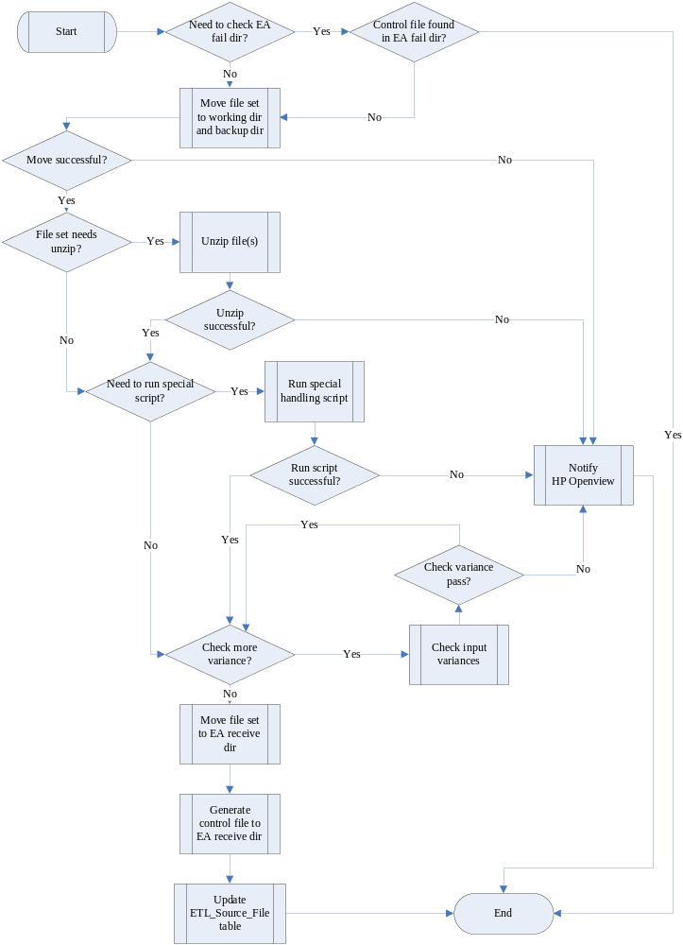

Pre-process related Directory
The following directories are used by the pre-process. Sub-directories of different data sources are indicated by <Data source> abbreviation code. The <Sys_date> represents a sub-directory for the ease of file housekeeping.

Directory (bill02:/opt/etl) | Example File | Description
~/preprocess/daemon/script | *.ksh | Scripts for the daemon
~/preprocess/daemon/config | adw_preprocess.cfg  exit.token | Configuration file includes:  - EA Database Name  - Database User Id  - Password  - Data Refresh Interval in Minutes  - Log Housekeep Days  Dummy file to control daemon life  The daemon will check itself and terminate if this exit file is found.
~/preprocess/daemon/log/<Sys_date> | adw_preprocess.log | Log file directory for the preprocess daemon.
~/openview | preprocess.log | Directory that contains log files monitored by HP Openview.
~/preprocess/<Data_source>/log/<Sys_date> | *.log | Log file directory for various data source processing
~/preprocess/<Data_source>script | *.ksh  *.pl | Directory for special handling scripts and DataStage extraction jobs.
~/preprocess/<Data_source>arrive | *.ctl  *.dat  *.gz | Data file directory at which pulled or extracted data files are located
~/preprocess/<Data_source>working | * | Working directory at which data files are under processing
~/preprocess/<Data_source>/backup/<Sys_date> | *.ctl  *.dat | Data file directory at which backup copy of pulled or extracted data files are located
~/preprocess/<Data_source>/rerun | *.dat  *.gz | Directory where data files are placed for rerun case
~/preprocess/<Data_source>/process | *.lock | Directory that contains lock information to keep track of process running status
~/DATA/fail | * | The directory at which the pre-process will check for previously failed EA job
~/DATA/receive | dir.<Filename>  <Filename> | Used by ETL automation  To place standardized control file and data file to signify EA to start a job

DATA Transformation AND loading approach
It should make suitable use of processing power of both DataStage server and Teradata server for transformation. In some cases, it may be simpler to implement transformation logic in DataStage. On the other hand, it may be more efficient to let Teradata to transform data by in-database table join.

Below are the general rules to determine where transformation will mainly take place:
Scenarios | Take place at
Small table mapping | DataStage
Field level transformation logic  Do not need to job with existing table | DataStage
Process with huge volume of data | Teradata
Join with a table already exist in database | Teradata

Four types of transformation approaches will be applied to different data according to their business needs.
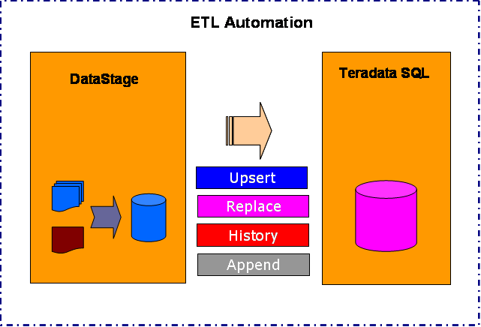

Upsert
In an Upsert job, a new record is either inserted into the table, or replaces an existing record.
- It searches to see if a record exists in the target table, based on the primary key.
- If the record exists in the target table, the record is updated to the target table.
- If the record does not exist, the record is inserted to the target table.

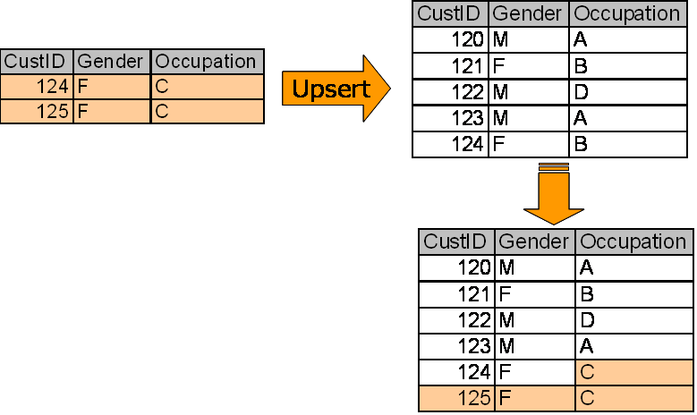

Replace
The logic is self-explained that the whole target table is just replaced by the source table.

History
There will be an extra “Change_Start_Date” and “Change_End_Date” in the record to represent the life of the data elements.
- The Delta file/table is compared with the master table
- If a change of any column in the record found, the original record at the master table will be marked old, with the Change_End_Date = ‘20050531’.
- A new record with Change_Start_Date = ‘20050601’ and Change_End_Date = ‘29991231’ is created and inserted into the master table.

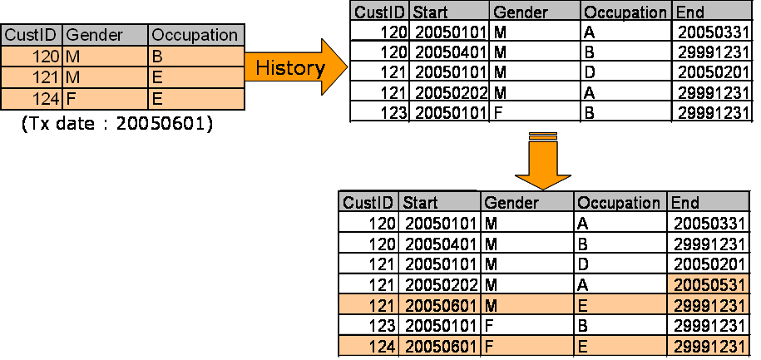

Append
The new arrival data is appended to the master table.

Table Image Switching Approach
In order to minimize the period of database object locking and for the ease of re-run handling, table switching approach will be used in some tables. This approach may be applicable for table which involves Upsert, Replace, History logic. However, this will not be used for Append nature transformation and CDR table transformation due to database space and performance consideration.

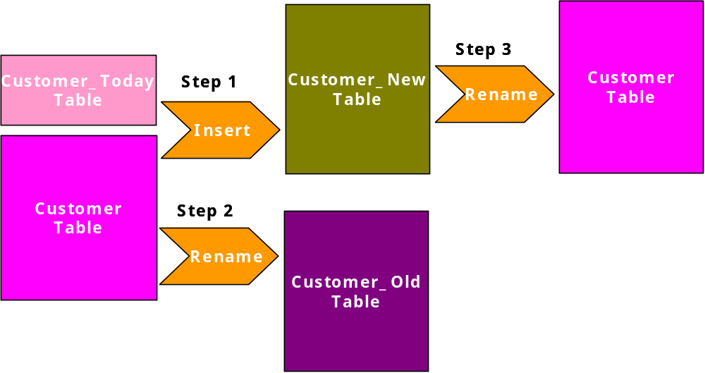

Processing Steps:
- During the processing of ETL, the existing table will not be updated. Instead, a new table (<Table>_new) will be inserted with the transformed data.
- The original table is then renamed to old tables
- Then, the new table is renamed to become the new master table for the date

CDR Table Implementation
Teradata MultiLoad utility will be primarily used for upserting data to huge CDR tables. This is taken the following into considerations:
- MultiLoad does not cause large transient journal.
- It provides checkpoints and restart capability after a load failure.
- It allows Upsert logic for loading data.

For smaller CDR tables, the table image switching approach may be used.

Duplicate Row Handling
There can be two ways to handle row duplication during loading. They may differ in some aspects:

Duplicate rows are skipped
Only one of the duplicated rows is loaded into table by FastLoad. Other duplicated rows are skipped. A post process will check the FastLoad log for the duplicate record count. If the count is non-zero, an additional script will run to capture these duplicate records into a data file for further follow up.

The capturing method involves a few steps:
- The original files in a set are concatenated into one file.
- The concatenated file is sorted.
- The concatenated file is sorted distinct to another file.
- The 2 files are diff’ed to produce the file storing duplicate rows.

Finally, HP Openview is alerted.

Duplicate rows are loaded
All duplicate rows are loaded into table. The table is defined as multi-set table with non-unique primary index. MultiLoad must be used for the loading. It returns successful also if duplicated rows are loaded.

The choice of handling method is subjected to individual job design.

Post processing

The post process is designed to capture some useful statistics from the job log files. These statistics are kept in database as historical data to serve the purpose of performance tuning as well as data quality control analysis.

Output Variance Checking
Two kinds of checking will be carried out at post ETL stage.

- Error Record Count
This includes rejected record count captured in error tables.

- Data Variance
This is the table field chosen to impose checking on its aggregated value.

- Output Record Count
The count of record loaded to table.

Any checking exceeding the margins will send message to HP Openview.

Table As_of_Date and Refresh_date
It requires a piece of information in the ADW to indicate the version of data image for the table. They will be updated whenever the table image changed. This is stored in the ETL_Table_Date table in the ADW.

The ETL_Table_Date contains the fields below:
Column name | Description
Table_Name | Table name in the ADW
As_Of_Date_Determine_Method | T – From a column in loaded table  F – From file, the ETL_SOURCE_FILE.Last_File_As_Of_Date will be used
As_Of_Date_Determine_Column | The column name storing the As_Of_Date information.  Only valid if As_Of_Date is determined from loaded table
Filename_Mask | Foreign key to ETL_Source_File.Filename_Mask
Data_Path | Foreign key to ETL_Source_File.Data_Path
Data_Retention_Period | A code representing the data retention period of the ADW table on monthly basis. E.g.  12+1  24+1
As_Of_Date_Offset | This is used to adjust the final table As_Of_Date.  0
As_Of_Date | Image date for the table
Refresh_Date | Last refresh date for the table

Determination of As_Of_Date and Refresh_Date

In general, there are several ways to determine the table image As_Of_Date, based on the availability of this date information following the priority below:

- By a date or timestamp field inside the data record
- By the YYYYMMDD portion of the data file name
- By the timestamp of the data file

The As_Of_Date will be of ‘timestamp(0)’ data type in the ADW repository. In the case that the time portion cannot be determined, the time portion will be filled by ’00:00:00’.

The Refresh_Date will be of ‘timestamp(0)’. It is the system timestamp captured at the end of job.

Table Collect Statistics
Table statistic is the key for the Teradata optimizer to choose appropriate execution plan. They should be collected at a regular basis to keep the information up-to-date. However, collecting statistics for large CDR tables will be very resource consuming.

In general, smaller table will be collected daily while larger tables will be collected weekly or monthly.

Syntax for collecting full statistics for a table:
- Collect statistics on <Table_Name> index (<Index_Columns>);
- Collect statistics on <Table_Name> column (<Columns>);

For huge tables, only sample of the tables are collected.

Syntax for collecting sample statistics for a table:
- Collect statistics using sample on <Table_Name> index (<Index_Columns>);
- Collect statistics using sample on <Table_Name> column (<Columns>);

etl Automation
All loading jobs including DataStage jobs, FastLoad, MultiLoad and Bteq scripts must be defined in ETL Automation. Each job will have its own running schedule and dependency. Inter-job dependencies are also linked up there. ETL Automation acts as the central point for job maintenance and scheduling.

Batch Window
There is no absolute time frame for pipelined extraction, loading, backup for the whole ADW. Each file or application specific file set will be processed on its own schedule. There generally two categories:

Night Batch Loading
For heavy loading jobs, they will be arranged to run during night time, no matter the required data file already arrived or not. The loading characteristics of these files will be set to time triggered so that its running time can be controlled.

Immediate Loading
The file will be loaded immediately upon data arrival. This is considered to be used for some small to medium size tables.

File Directory Flow
The following diagram describes the file flow among different directories in pre-process and ETL Automation processing.
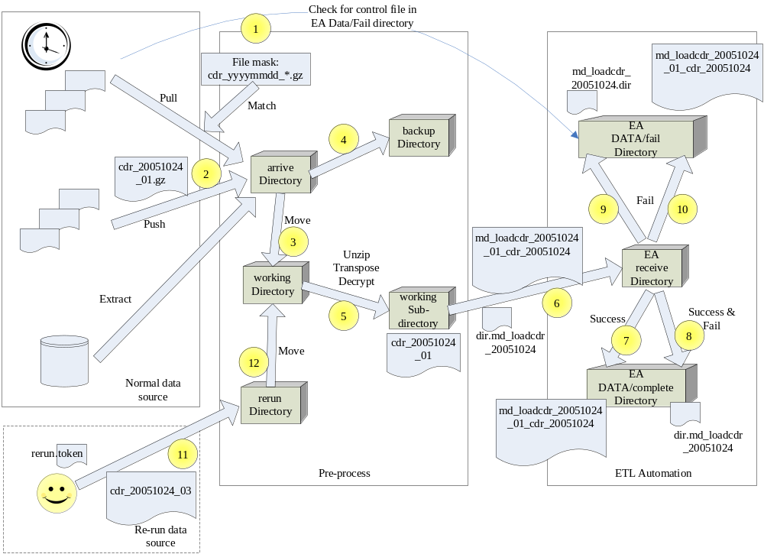

- If Check_EA_Fail_Dir_Flag is set, it firstly checks if file name mask has previous failed job from EA ~DATA/fail directory.
- If no previous job failed, the data files are matched using the file name mask. Matched data files are moved to their own arrive directory.
- The Monitor daemon will check the arrive directory by periodic time interval. To process a file set, the files are moved to a separate working directory. This can avoid ambiguity of more new files being pushed in.
- A copy of the file set is also copied to backup directory. This copy is used for future troubleshooting and re-run.
- The file set is further moved in a run-time determined sub-directory (By system date time and process id). At which, specific processing is carried out (E.g. Unzip, transpose, decrypt, Excel file massage). Validations will be imposed also.
- After validation passed, data files are moved to EA arrive directory, followed by a control file.
- If an EA job failed, the control file (Renamed from “dir.XXX_yyyymmdd” to “XXX_yyyymmdd.dir”) will be additionally moved to EA ~/DATA/fail directory. The original control file (without rename) will move to the ~/DATA/complete directory.
- If the job complete successful, the control file will be moved to EA ~/DATA/complete directory only.
- Data files are moved to ~/DATA/fail directory if job is failed.
- Data files are moved to ~/DATA/complete directory if job is successful.
- In case of re-run, new data files are prepared and placed at the rerun directory for its data source group. After all files for this re-run are placed, a special named token (I.e. rerun.token) is touched at the directory also to indicate the starting of re-run.
- The monitor daemon will treat the data files for re-run and move to working directory for further process.

Running Jobs Multiple Times a Day in ETL Automation
ETL Automation is originally designed to normally run a job once a day, based on its $TXDATE parameter. EA will prohibit further triggering of a job that has been run within a date. However, one can manually reset the job status to trigger the 2nd and subsequent runs.

In order to allow EA to trigger the same jobs multiple times a day automatically, it requires to have the “Do Not Check Job Last Status” flag checked. Hence, EA will bypass checking on the status of previous run, so that a job can run multiple times.
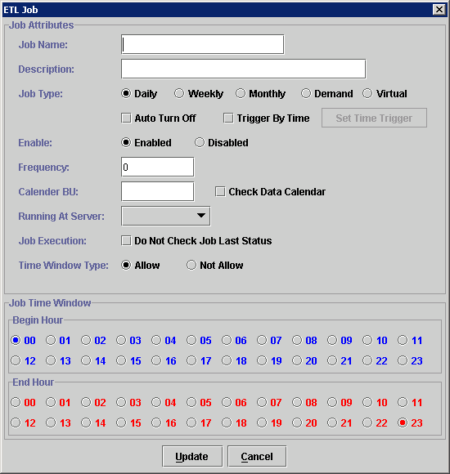

Job Re-run
In case of job failure, support staff will be alerted, and then appropriate fix will be applied. Sometime it involves script change, and sometime it involves data patching. After the data or related jobs are fixed, in general, there are two entry points for rerun.

Restart from the Pre-process

New data files are prepared to the rerun directory. A special named file token is touched to the rerun directory. The pre-process daemon will capture the token and move the files for re-run.

Restart Jobs via ETL Automation

The ETL Automation provides a client GUI for job scheduling and setting. Job statuses in the EA repository are reset from this client interface. Then, the job will be restarted after checking further dependencies. After successful completion, dependent jobs and down stream jobs will be started automatically.

ETL Automation Directory
All the job scripts are located at the Sun Solaris server (bill02). The three major components (Pre-process daemon, ETL automation service and DataStage jobs) must follow this directory structures. The following table describes the directories and their purposes.

Directory (bill02: /opt) | Description
~/etl/APP/bin | For storing ETL job scripts
~/etl/DATA | For storing EA data files and control files
~/etl/LOG | For storing EA job logs
~/etl/bin | For storing EA program jobs
~/etl/axm | For storing loading access modules shared objects
~/etl/etc | For storing miscellaneous files
~/etl/lock | For storing locking file for EA internal processing
~/etl/tmp | Temp directory for EA

password encryption
In order to allow batch loading jobs to access Teradata database, we keep the encrypted database logon string in a protected file. This is achieved by using the password encryption module ‘EncodeLogon.pl’ provided by ETL Automation. Whenever a password is needed, job script will call a decryption module ‘IceCode’ to decrypt it and store it as local variable within the job.

HP Openview
HP Openview will be the primary console for monitoring the whole ETL process. Several components will send message for critical errors:

- The pre-process daemon will send error message if invalid file is encountered.
- ETL will also report job loading error as well as post-ETL checking failure.
- The usage of disk for the staging area should also be monitored by HP Openview.

In order to achieve these message communications, several directories and logging files are agreed to achieve monitoring purpose.

Directory (bill02: /opt/etl ) | Log Files | Reported from
~/openview | ea.log | ETL Automation
~/openview | preprocess.log | Pre-process daemon

Appendix

etl automation operation introduction

Overview
ETL Automation (EA) acts as job scheduler of the data loading and transformation in ETL operation. The elementary operation unit of EA is JOB. EA manages job by application systems and keep it in different directories. Each job will serve its own purpose like data loading, transforming.

To create a new ETL System, choose a predefined ETL System under the “ETL System” tree item in the System Panel. Then select Job > Add ETL Job from the menu bar or click the add ETL Job icon from the tool bars.

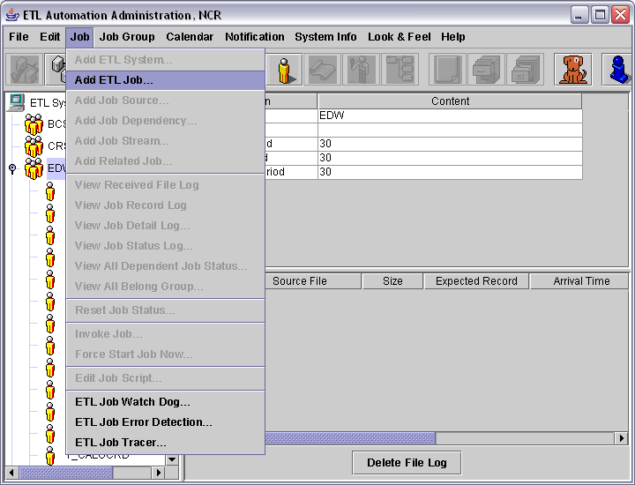

Then ETL job dialog box will be shown up as below:
To create an ETL Job, you must fill in the following details:

Job Name: A unique name for the job with a limit of 50 characters.
Job Description: A short description for the job with a limit of 50 characters.
Job Type: Daily – indicate the job is running everyday.
Weekly – indicate the job is running weekly.
Monthly – indicate the job is running monthly.
Demand – indicate the job only runs on demand.
Virtual – indicate a virtual job.
Auto Turn Off: If user chooses this option, the job will be disabled after the job is complete.
Trigger By Time: If user choose this option, the job will start automation by defining the running period of the job.
Enabled/Disabled: Choose to enable or disable the ETL Job.
Frequency: By assigning a value to the Frequency field, user can control the running period of the job. Example: by inputting “1, 10” in this field, the job will only process on 1st and 10th. EA will check the transaction of the control first before continuous to process. The valid values for this field are:
0 – everyday
-1 – end of the month
1 to 31 – 1st, 2nd…31st
41 to 47 – Monday, Tuesday…Sunday
Calendar BU: The name of the business unit.
Check Data Calendar: By choosing this option, EA will check the transaction date of the control file to make sure it follows the sequence in the data calendar.
Running At Server: The server where the job is going to be run.
Do not check job last status: By disable this option, job can only be run when the last job status is complete.
Time Window Type:
Allow – By choosing this option, the time specify in Job Time Window will become the time that allow the job to run.
Not Allow – By choosing this option, the time specify in Job Time Window will become the time that do not allow the job to run.
Begin Hour/End Hour: By choosing the different option from the Time Window Type, the time period specify here will be the allow/not allow time period for the job.

After you have input all the details of the job, you can press “Update” to add the new job or “Cancel” to deny any changing.

To modify the setting of an ETL Job, you only need to click on the name of an existing ETL Job from the “System Panel”. Then on the menu bar select Edit > Property or you can click the property icon showing on the window.

To delete an existing ETL Job, first you need to click on the name of an existing ETL Job form the “System Panel”. Then on the menu bar select Edit > Delete or you can click the delete icon showing on the window. Next a dialog box will show up and ask to confirm deleting the selected item. Choose “YES” to delete the ETL Job or “NO” to cancel the action.

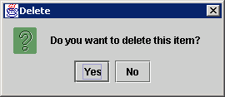

Different job relation can be setup among jobs. They are Job Stream and Job Dependency:

- Job Stream is the mechanism to kick-off downstream job when upstream job is completed. If job B is a stream job of job A, then after job A (upstream job) is finish, job B (downstream job) will start to run automatically if no other Job Dependency is outstanding.

- Job Dependency is the mechanism in designing job flow to specify a pre-requisite condition for a specific job. This pre-requisite condition can be a job completion or an arrival of a file. Dependency not like a Job Stream that a job it can be run automatically when dependency condition is satisfied. E.g. If job A is a dependency job of job C, then job C must wait until job A is completed.

In EA, Job Stream and Job Dependency can be easily setup from ETL Automation Administration by the following step:

Job Stream Setting:
- Choose the “Add Job Stream” icon in the ETL Administrator program and the “ETL Job Stream” window will be opened.
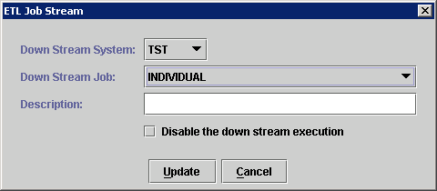

- Choose system name from Down Stream System pull-down.
- Choose the name of the down stream job from the selection list and enter a short description about the job.
- Job Stream can be disabled by clicking “disable the down stream execution” option. It can be enabled at any time later by editing the Job Stream’s property.

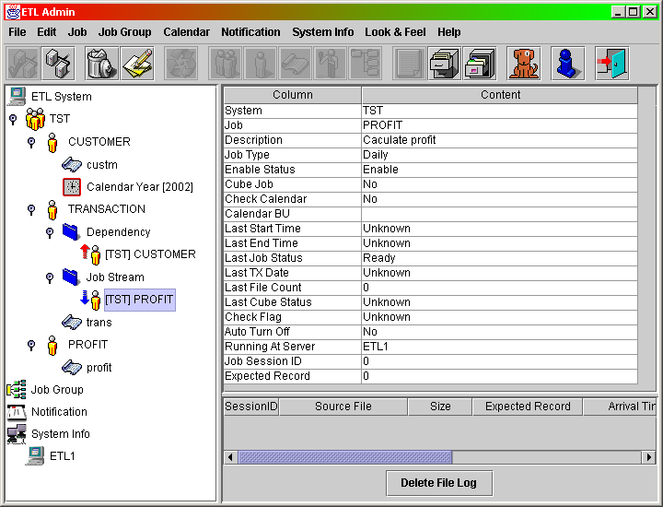

Job Dependency setting:
- Choose the “Add Job Dependency” icon in the ETL Administrator program and the “ETL Job Dependency” window be opened.

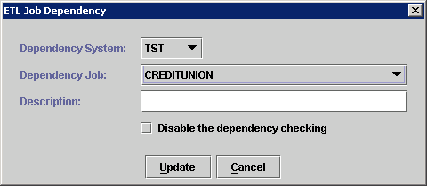

- Choose system name from Dependency System pull-down.
- Choose the name of the dependency job from the selection list and input a short description about the dependency job.
- Job Dependency can be disabled by clicking “disable the dependency checking” option. It can be enabled at any time later by editing the Job Dependency’s property.

Each EA job is invoked by a control file. A daemon program called etlrcv will monitor the RECEIVE directory (/opt/ETL/DATA/RECEIVE) to check if any control file is coming. If a control file is found, it will fork a process to invoke etlslave.pl in order to execute the ETL Job if the following criteria are fulfilled for the job:

  - Transaction date of the control file must be greater than or equal to transaction date of the job
  - Data file’s size and filename must be the same as the content in the control file.
  - It’s dependent jobs must been completed
  - Job script in Perl must exist in the directory as specified in job setting.
  - The job must meet it’s time window to be run. (I.e. we can set the job to be run between 0:00a.m. to 1:00a.m., so if the control file comes at 2:00a.m., the job is not allowed to run.)

ETL Automation acts as centralized job scheduling and controlling center for the whole ETL process. For details of operation and configuration, please refer to ETL Automation User Manual.

Daily and Monthly Job Setting

EA jobs are either invoked by supplying a control file or triggered by an existing job. However, the control file may arrive at a earlier or later time. It affects the actual job execution time.

We can configure job trigging method and running frequency by editing the job’s attributes in ETL Automation.

Trigger by Control File

By choosing different job type and assigning different value to the frequency field, we can control job to run if the transaction date of the control file match with the frequency setting.

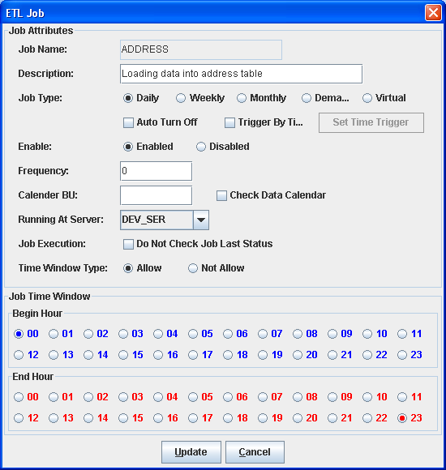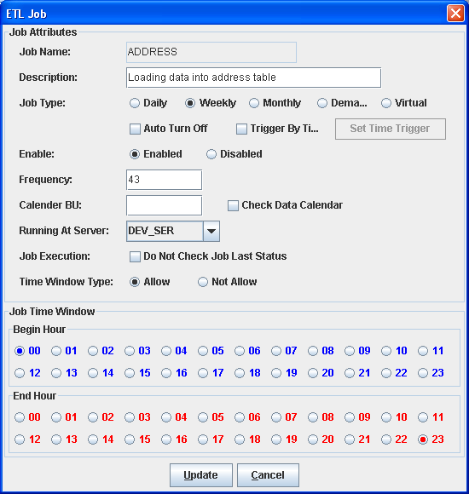

Different frequency code as follow:
0 means every day, -1 means the last day of month, 1 to 31 means the day number in a month, 41 to 47 means the day number in a week.

For example:

Suppose we only want the job running at every Wednesday, we can do it by choosing the weekly option and assign 43 to the frequency field. Also if we want to change the job to run at the end of each month, we can choose the monthly option for the job type and assign -1 to the frequency field.

Then when the control file arrived, EA will check the transaction date of the data file and design whether to run the corresponding job.

Environmental Parameter File
In ETL job coding, an environment parameter file ‘etlvar.pl’ will be used to control either development, UAT or production are being processed. It also helps to parameterize our job design to allow same piece of codes to work in different environments and enhances the script usability. In ETL Automation, the parameters in the parameter file will be extracted when kick-off the job and passing the parameter job’s internal variable for job use.

Datastage operation introduction

In ETL process, we will use DataStage to perform some of the data loading job as data reformatting task. DataStage GUI environment allows user to use drag and drop approach to develop job and generate FastLoad scripts for the data loading to Teradata automatically. This feature can help to speed up the development time and let developer more focusing on the job design.

DataStage can be divided into two parts – server side and client side. DataStage Server is the server application which responsible for executing job. There are four DataStage client applications used in ETL for building, controlling and monitoring job in DataStage. The four applications and their functions are listed as below:

- DataStage Administrator – To perform administration tasks in DataStage. These include creating and moving projects, setting up DataStage users and setting up purging criteria.

- DataStage Designer – A design interface used to create DataStage Jobs. Each job specifies the data sources (i.e. database, sequential file…etc), the transformation required, and the destination of the data which is the Teradata database in our case. Finally, jobs are compiled to create executables that can be run by the server.

- DataStage Director – A user interface used to validate, schedule, run, and monitor DataStage server jobs and parallel jobs.

- DataStage Manager – A user interface used to edit and view the contents of the DataStage repository.

To start DataStage client, we need to create a project from DataStage Administrator first. Project is used for storing DataStage jobs and user-defined components. After a project is created, we can create jobs in DataStage Designer and manage any DS job components in the DataStage Manager.

DS job requires to be compiled before execution, and then we can develop an EA job to kick-off by DS command line prompt ‘dsjob’.

ETL Performance tuning

There are several features that may help to improve ETL performance. The choices of implementing these features are subject to actual job performance and workload. There are two major Teradata features helping this.

Partitioned Primary Index
For some large table like CDR tables, as well as medium size tables, Partitioned Primary Index (PPI) is applied to improve query performance.

Partition Columns should be determined during PDM design. For the re-definition of PPI on existing table, its structure needs to be modified by recreating its DDL. Then, the data is repopulated. Data rows inside the PPI table are ordered by Partition Number, and then by Row Hash (actually Row ID) sequence within the Partition. This design can help optimization for range queries to eliminate non-candidate partitions.

All history tables and transaction tables should have Partition Primary Index defined. History tables are generally partitioned by end date while transaction tables are partitioned by transaction date.

For the details on the choice of partitioned columns, please refer to the PDM design documents.

Secondary Index
Secondary Index can be built on specific tables to give query alternatives on the data access path. This may or may not gain improvement on query performance. Therefore, this should be evaluated and determined case by case.

Identifiable Error Messages
The following are messages that may send to HP Openview

Check Phase | Error Condition | Severity | Checking Target | Rule | Action
Pre-ETL Check | File not found at expected time | Information | File | Interface file is expected to be pulled from a dir location, but not found yet | Wait for an interval and retry
Pre-ETL Check | File not found after a number of retry | Warning | File | Interface file is expected to be pulled from a dir location, and retry failed for N times | Send message to HP Openview
Pre-ETL Check | File set incomplete at expected time | Information | File | Set of interface files is expected to exist at a dir location, but not found yet. | Wait for an interval and retry
Pre-ETL Check | File set still incomplete after a number of retry | Warning | File | Set of interface files is expected to exist at a dir location, but not found and retry failed for N times. | Send message to HP Openview
Pre-ETL Check | Machine cannot be reached | Critical | File | The Ip address of the file location is not reachable | Send message to HP Openview
Pre-ETL Check | Machine login failure | Critical | File | Cannot login the machine to get the required file | Send message to HP Openview
Pre-ETL Check | Failure in head trailer validation | Error | MD File | Validate head/trailer based on file | Send message to HP Openview
Pre-ETL Check | Failure in input variance rule checking | Error | File | Produce an error when a rule is failed to pass in pre-process checking | Send message to HP Openview
Post-ETL Check | Failure in output variance rule checking | Error | Table | Produce an error when a rule is failed to pass in post-ETL checking | Send message to HP Openview
ETL Check | Job script failure | Error | File | Failure in a job run | Send message to HP Openview

